Measuring Air Quality Index to Evaluate Pollution Level in Mogadishu City Using IoT Sensors
Mowliid Sh Abdullahi Mohamed¹, Amal Mohamad Abdi², Omar Abdullahi Ahmed³,
Ahmed Abdi Hussein⁴, Abdullahi Mohamud Hassan⁵
engjikoota@gmail.com¹, Caziizacadey2@gmail.com², Haadiyare3313@gmail.com³ cumarbilecabdulaahi10@gmail.Com⁴ beerey007@gmail.com⁵
Faculty of Computer and Information Technology
Jamhuriya University of Science and Technology Mogadishu-Somalia

ABSTRACT Air pollution is the largest environmental and public health challenge in the world today. It leads to adverse effects on human health, climate, and ecosystem. Air is getting polluted because of the release of Toxic gases by industries, vehicular emissions, and increased concentration of harmful gases, this necessitates a proper real-time measurement and analysis of air quality so that appropriate decisions can be taken in a timely period. In this work a system of measuring air quality index for Mogadishu city is proposed and implemented using IoT technology, C++ programming language and mobile programming. Evaluation and measurement of the air pollution were performed according to WHO guidelines with each level categorized by symbolized colors. To get the results of this investigation, we used some devices such as MQ3 for smoke sensors and air quality level for real- for the mobile e, NodeMCU send data to cloud firebase and data are shown in mobile application

Keywords Index Air Quality, Air Pollution, MQ3 gas sensor, NodeMCU, Cloud firebase, Arduino Uno,
I. Introduction
Air pollution is a major concern of the new civilized world, which has a serious toxicological impact on human health and the environment. It has several different emission sources, but motor vehicles and industrial processes contribute to the major part of air pollution. According to the World Health Organization, six major air pollutants include particle pollution, ground-level ozone, carbon monoxide, sulfur oxides, nitrogen oxides, and lead. Long- and short-term exposure to air-suspended toxicants has a different toxicological impact on humans including respiratory and cardiovascular diseases [1]
To mitigate the impacts of air pollution on human health, the global environment, and worldwide economy, governments have put tremendous efforts into air pollution monitoring the 1972 UN conference on the environment in Stockholm called for a concerted assault on all worldwide natural pollution issues. The United Countries Environment Program (UNEP) was made, and in association with the World Health Organization (WHO) started to address the issues of urban air contamination which were exemplified by the 1952 London Fog in which over 3000 individuals died [2].
According to World Health Organization [3] In the last century, the massive extent of emissions of air pollutants due to the financial and industrial increase has made air nice the main hassle in many industrialized countries, and emerging trouble for the rest of the world. Increased concentrations of greenhouse gases, in particular CO2, in the earth’s surroundings have already warmed the planet substantially, inflicting more severe and prolonged warmness waves.
Ambient air pollution is a major global public health problem, affecting both developing and developed countries. Many developing countries derive energy from natural, inexpensive sources for industrial, commercial, and living purposes, but do not have sufficient technologies to mitigate potential air pollution arising from these energy sources. According to the World Health Organization (WHO) Ambient Air Pollution Database, derived from measurements taken in 1600 cities in 91 countries, almost nine out of ten individuals living in urban areas are affected by air pollution [4].
Also, Africa as of now has the quickest developing populace within the world, anticipated to more than twofold between 2010 and 2050, outperforming two billion (UN 2011). By 2050, about 60 % of the populace of Africa is anticipated to be living in cities, compared to less than 40 % in 2011 (UN 2012). Urbanization, coupled with expanded industrialization, developing proprietorship of engine vehicles, and preceded utilization of biomass as a household vitality source, may lead to a significant declining in air quality across the landmass. [5].
According to [6] The air quality index (AQI) is a scale used in determining the air quality of an area. It focuses on the health effects that may be experienced within a few hours or days after the inhalation of the polluted. The Environmental Protection Agency (EPA) targets to “protect human fitness and the environment” (the United States Environmental Protection Agency, 2017). One of the fundamental subjects of environmental problems it is involved with is the condition-- how clean or polluted-- of air. two Some approaches to measuring air quality is using
There is sever a study that links air pollution to human fitness effects. With regards to trees, most research has investigated the magnitude of the impact of bushes on pollution removal or concentrations, whilst solely a limited number of studies have looked at the estimated fitness effects of air pollution elimination by way of trees. In the United Kingdom, woodlands are estimated to stop between five and seven deaths and between four and 5 health center admissions per 12 months due to reduced air pollution of sulfur dioxide and particulate remember [7].
The effects of air pollution on people have been the subject of research around the world to correlate the photochemical effects of air and health, the respiratory system, and the aggravation of allergic diseases reported that the world suffered economic losses of 129 billion USD in association with Greenhouse gas (GHG) emissions in 2016. Researchers from different countries have been united in their quest to correlate the effects of air pollutants with respiratory diseases.[8].
Recent worldwide increases in air pollution have created a wide spectrum of health complications for citizens and increased mortality rates in urban areas. A very thorough study done by the Global Burden of Diseases, published in 2017, showed that 4.2 million deaths were attributed to the influence of air pollution in 2015. Governments around the world have recognized this threat and are already prioritizing air pollution as a major global concern, creating policies for its accurate monitoring and mitigation [9]

II LITERATURE SURVEY
Air pollution has become a problem across the globe and is still arising as a major concern in a country with a booming economy. In the Philippines, laws were outlined to reduce air pollution and incorporate environmental protection into its development plans. However, limited means to conduct air quality monitoring that could determine if the standards in the National Ambient Air Quality Guidelines are met have been implemented. This study aims to design and create a system that could monitor the surface air quality from the different distant zones of a local municipality [10]
RELATED WORKS
Discuss contamination analysts distributed and secured numerous of indoor and open-air discuss contamination issues. A huge number of discuss contamination based on WSN inquires about were distributed to unravel and identify the issue of discussion defilement.[11]
In [12] a checking framework is created which gives the centralization of Carbon-di-oxide of far off territory. The framework additionally reports temperature dampness and light force of the outside observing territory. Thus, an urban CO2 checking framework was introduced by the creator. The framework works outside at an urban territory around 100 square kilometers.
A WSN approach for IAQ observing dependent on the Waspmote stage utilizing ZigBee correspondence innovation for information transmission is proposed by [49]. The sensor hubs have minimal effort temperature, moistness, CO, and CO2 sensors for information procurement, yet also proficient hardware for PM management, in particular, DUSTTRAK DRX 8533 Aerosol (TSI, Shoreview, MN, USA). The gathered information can be seen utilizing a work area application created in Java. The base station gets IAQ information from a few indoor areas sent by the sensor's hubs [13]
Numerous monitoring solutions are available in the literature; here, we describe some of them. Several IoT architectures for IEQ monitoring are proposed. They incorporate open-source technologies for data processing and transmission, as well as microsensors for data acquisition. These architectures allow access to data collected from different sites simultaneously through Web access and mobile applications in real-time [14].

III. Methods and materials
The concept of build air quality monitoring is similar to the company which guides the environment health because of the technology that we use, in which we can guide the air quality monitoring. We can build a smart air quality monitoring by using MQ3 gas sensor and NodeMCU.

A Requirements
1- Hardware requirements: this requirement concern the hardware we going to use to develop an Air Quality monitoring system.
a- NodeMCU is an open-source platform-based firmware developed for ESP8266 Wi-Fi chip NodeMCU firmware that comes with ESP8266 Development board/kit i.e. NodeMCU Development board
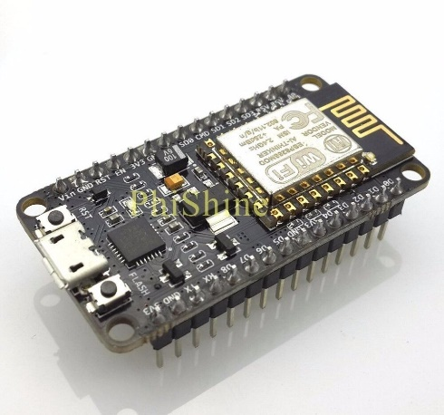
Fig 1 NodeMCU

b-Arduino UNO(Arduino is an open-source platform and easy to use) and is used to read the energy consumption data from the meter when appliances are connected.
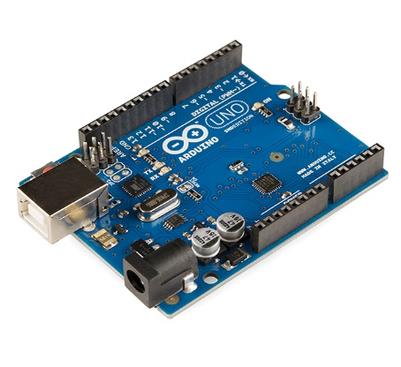
Fig 2 Arduino Uno

c- GSM 900a module (This modem is generally used for SMS in many embedded system projects) and is used to receive and send SMS codes from/to the controller and the mobile phone.
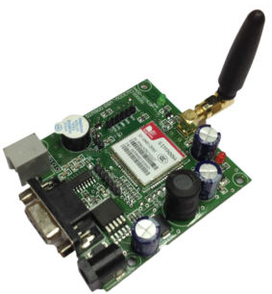
Fig 3 GSM-Module

d- MQ3 gas sensor this sensor provides an analog resistive output based on alcohol concentration. When the alcohol gas exists the sensor’s, conductivity gets higher along with the gas concentration rising. There is the resistance across an A and B inside the sensor which varies on the detection of alcohol
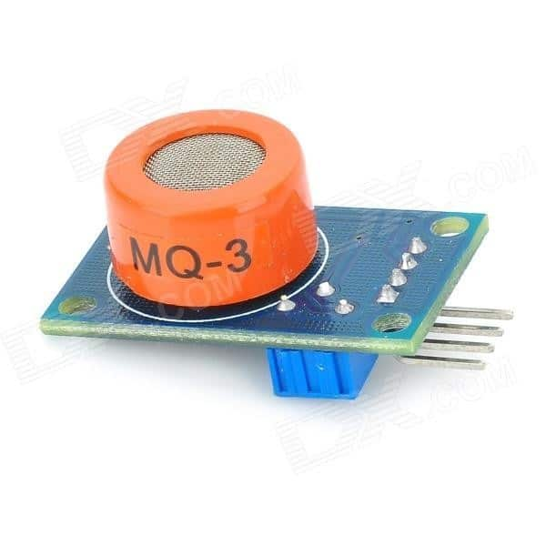
Fig 4 MQ-3 Gas Sensor

2- Software requirements specification (SRS) is a description of a software system to be developed, the software requirements specification document lists sufficient and requirements for the project development
a- For programming of Arduino IDE software is used. Arduino integrated development environment (IDE), which is across platform application written in the programming languages processing and wiring It has a code editor with a tool like a text cutting and pasting, searching and replacing text automatic indenting, brace matching, and syntax highlighting and provides a very easy one-click process to compile and upload programs to an Arduino board
b- Android application development he mobile operating system Android includes Google. Play market with access to over 2.7 million user-developed apps In the Early days of Android app development, developers either relied on the Eclipse IDE with the Android Development Tools (ADT)plugin or the NetBeans IDE with the plugin for writing apps In December 2014 Google released the Android Studio IDE based on JetBrains IDE which functions together with the SDK as officially supported Android IDE. Features of Android Studio include a Gradle-based build system, Android Device emulator fortes ting apps
c- Firebase is a combination of Google's many services in the cloud, including instant messaging, user authentication, real-time database, storage, hosting, and so on. This study mainly uses its user authentication and real-time database functions, supplemented by instant messaging, to complete the event notification and SMS notification function Firebase cloud system provides encrypted data transmission
The most quintessential components or offerings presented by Firebase are:

Real-time Database:
Realtime Database is a cloud-hosted database. Data is saved as JSON and synchronized continually to every related client. When any cross-platform application is developed with iOS.
Authentication:
Firebase Authentication offers backend services, simple-to-use SDKs, and immediately UI libraries to affirm purchasers over an application. It helps authentication using passwords, email id or username, smartphone number, etc. Users can be allowed to signal into a Firebase app either through the use of Firebase UI as a whole drop-in authentication answer or by using the usage of the SDK to manually combine one or a few sign-in techniques
c- MySQL database Its community-developed fork MariaDB is an open-source relational database system with advanced replication and clustering features. is a standalone and is an Oracle-backed open-source relational database management system (RDBMS) based on Structured Query Language (SQL)? MySQL runs on virtually all platforms, including Linux, UNIX, and Windows. the MySQL Database Software is a client/server system that consists of a multithreaded SQL server that supports different back ends, several different client programs and libraries administrative tools, and a wide range of application programming interfaces (APIs)

IV Analysis & Design
In this chapter, we focus the analysis and design of the air pollution monitoring system in Mogadishu using Arduino which is an important phase when developing systems such as IoT (Internet of Things). The requirement of the system can be two main parts Functional and Non-Functional Requirements the functional requirements explain the necessary function of our system which are unique to the system, also in the non-functional requirements are discuss the common functions of the system.

A System Design
In this section discuss the proposed system design. Firstly, the MQ-3 gas sensor send data to NodeMCU which is used to transmits data to cloud firebase. The cloud connects to mobile application to show the result from MQ-3. Secondly, MQ-3 send data to Arduino and connect to GSM module which sent SMS about air quality number and level name to mobile phone.

Fig 5 System Design

B Flow chart
Flow chart: The flow chart is shown information about how the system works. The system stapes is the following. The first you start a mobile application and log in to the system if login filed pleas try again else if login successful you can get system dashboards as user or admin. if you are a user you have full control of the system. Flowcharts are used in designing and documenting simple processes or programs. Like other types of diagrams, they help visualize what is going on and thereby help understand a process, and perhaps also find less-obvious features within the process, like flaws and bottlenecks
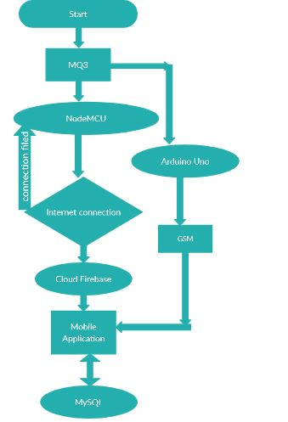
Fig 6 Flow chart Diagram
Arduino Uno is programmed to read and send SMS as this is the major means of communication between the modem (SIM900) and the controller. Information sourcing is done by composing an SMS message using the appropriate command format and sending it to the mobile phone number. The SMS is received by the GSM modem and transferred to the Arduino Uno controller.

The ESP8266 Wi-Fi Module is a self-contained SOC with an integrated TCP/IP protocol stack that can give any microcontroller access to your Wi-Fi network. The ESP8266 is capable of either hosting an application networking functions from another application Each ESP8266 module comes pre-programmed with an AT command, NodeMCU is programmed to read data from the MQ3 gas sensor to Firebase and this is the main aim of NodeMCU in our project.

The MQ-3 alcohol sensor consists of a tin dioxide (SnO2), a perspective layer inside Aluminum Oxide microtubes (measuring electrodes), and a heating element inside a tubular casing. The end face of the sensor is enclosed by a stainless-steel net and the backside holds the connection terminals. Ethyl alcohol present in the breath is oxidized into acetic acid passing through the heating element. With the ethyl alcohol cascade on the tin dioxide sensing layer, the resistance decreases. By using the external load resistance, the resistance variation is converted into a suitable voltage variation.

V. Implementation
This section will discuss the tasting and implementation of the application. which is the most significant piece of our research, and to protect that Codes are working accurately. it will include the software and hardware specification which was defined in the previous section.

A Setting up NodeMCU
Now Let’s connect the ESP8266 module to your computer through USB cable as shown in the figure. When the module is connected to the USB, COM port is detected eg: here COM5 is shown in the figure.

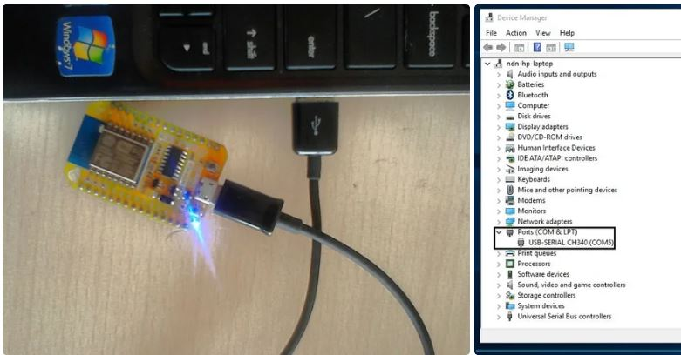
Fig 3 NodeMCU Connect to Computer

MQ-3 Alcohol Sensor Circuit Schematic
The alcohol sensor circuit we will build with an MQ-3 sensor integrated with a NodeMCU is shown below.

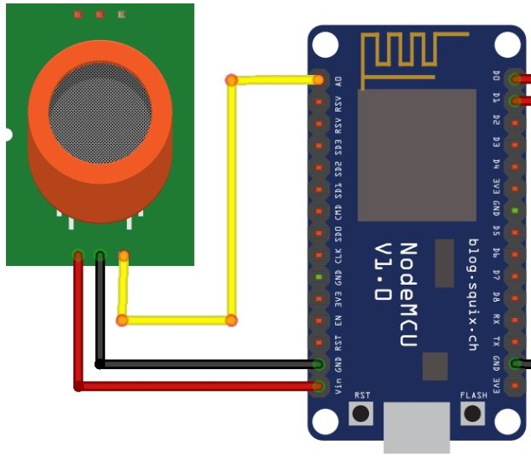
Fig 7 MQ-3 Connect to NodeMCU

B Arduino Uno and GSM Module
Global System for Mobile communication (GSM) is a digital cellular system used for mobile devices. It is an international standard for mobile which is widely used for long-distance communication, The GSM connect to Arduino Uno is shown below. if the pollution number increases the gsm module sends short message service SMS to a mobile number.

C Creating a Firebase Database

Firebase is a mobile-backend-as-a-service that provides powerful features for building mobile apps. Firebase has three core services: a Realtime database, user authentication, and hosting. With the Firebase iOS SDK, you can use these services to create apps without writing any server code.

Fig 8 Creating Firebase

How Does the Air Quality Index Work?

In more than 800 counties across the nation, air pollution levels are measured daily and ranked on a scale of 0 for perfect air up to 500 for air pollution levels that pose an immediate danger to the public. The AQI further breaks air pollution levels into five categories, each of which has a name, an associated color, and advice to go along with it.
International institutions reflect on consideration on six major pollutants which categorized
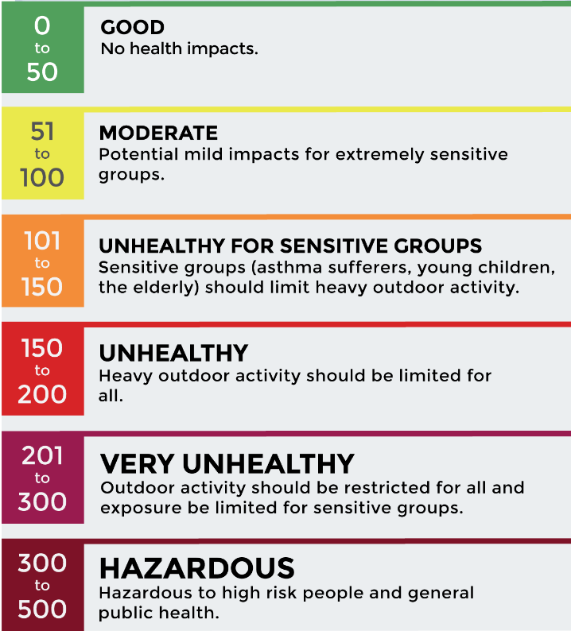
Fig 9 Air Quality Index
The system was successfully finished and tested it with all the considerations possible. and the result of the system shown in Mobile application, convenient and has a friendly user interface which makes the system

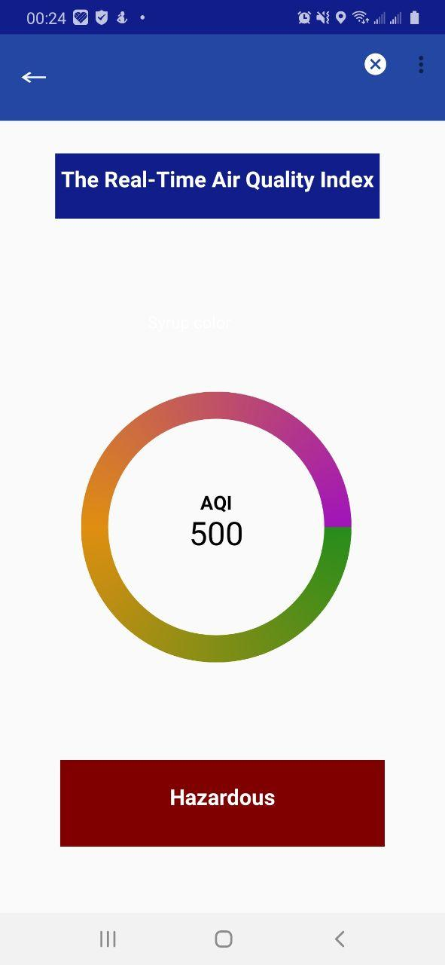
Fig 10 Air Quality Index for Mobile

Finally, we collected data about air quality level in some district in Mogadishu Somalia, Yaqshid, Heliwaa Hodan, Warta Nabada, and Howlwadag and we get the following air quality reports

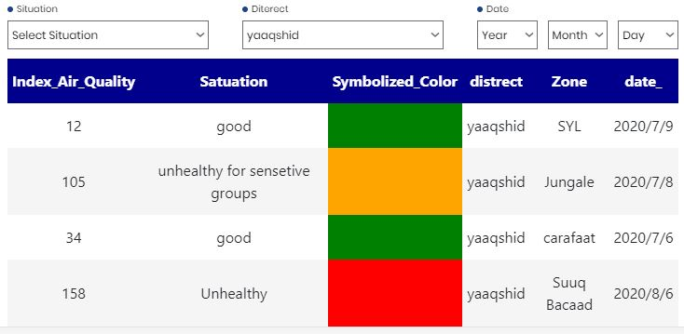
Table 1 Yaqshid Air quality Index
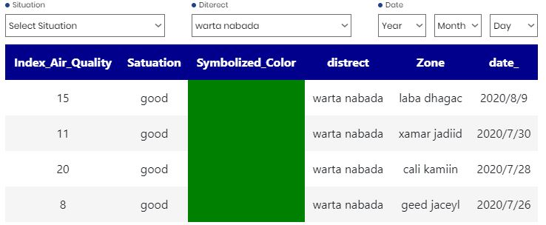
Table 2 Warta Nabada Air quality Index

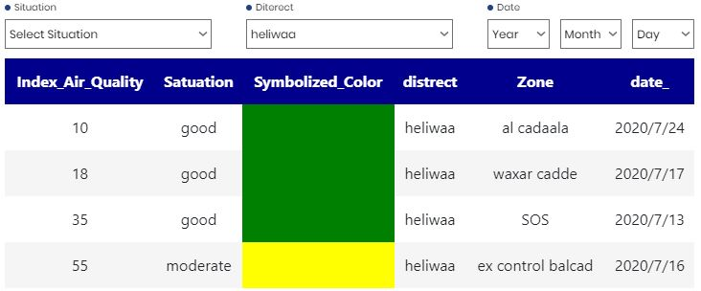
Table 2 Heliwaa Air quality (report)

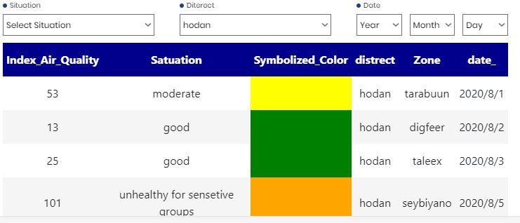
Table 4 Hodan Air quality Index

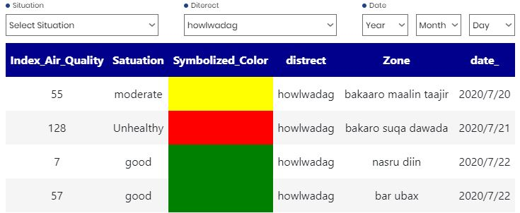

Table 5 Howlwadag Air quality Index

VI. CONCLUSIONS AND FUTURE WORK
This study presented a mobile application; That enable the users to measure and classify the level of the air pollution in Mogadishu, Somalia using the Internet of Things (IoT) successfully. The future work of this project will include the following prospects: 1) Create a network of wireless gas sensors to cover more than one place simultaneously for monitoring the AQI during 24 hours; 2) Improve Portable system, Investigation of installing a system with an external battery and makes as possible to run for everywhere. without computer or laptop
References
[1] Sai, K. B. K., Subbareddy, S. R., & Luhach, A. K. (2019). IOT based Air Quality Monitoring System Using MQ135 and MQ7 with Machine Learning Analysis. Scalable Computing: Practice and Experience, 20(4), 599-606
[2] Jo, J., Jo, B., Kim, J., Kim, S., & Han, W. (2020). Development of an iot-based indoor air quality monitoring platform. Journal of Sensors, 2020.
[3] Cruz, L. A. A., Griño, M. T. T., Tungol, T. M. V., & Bautista, J. T. (2019). Development of a Low-Cost Air Quality Data Acquisition IoT-based System using Arduino Leonardo. International Journal of Engineering and Manufacturing, 9(3), 1
[4] Mokrani, H., Lounas, R., Bennai, M. T., Salhi, D. E.,& Djerbi, R. (2019, August). Air quality monitoring using iot: A survey. In 2019 IEEE International Conference on Smart Internet of Things (SmartIoT) (pp. 127-134). IEEE.
[5] Mokrani, H., Lounas, R., Bennai, M. T., Salhi, D. E., & Djerbi, R. (2019, August). Air quality monitoring using iot: A survey. In 2019 IEEE International Conference on Smart Internet of Things (SmartIoT) (pp. 127-134). IEEE.
[6] Yamunathangam, D., Pritheka, K., & Varuna, P. (2019). IoT enabled air pollution monitoring and awareness creation system. Int. Jrnl. of Recent Techn. and Eng., 7(4), 398-400.

[7] Firdaus, R., Murti, M. A., & Alinursafa, I. (2019, November). Air quality monitoring system based internet of things (IoT) using LPWAN LoRa. In 2019 IEEE International Conference on Internet of Things and Intelligence System (IoTaIS) (pp. 195-200). IEEE.
[8] Kumar, P., Agarwal, A., Purohit, G., & Raju, K. S. (2019, February). Intelligent home with air quality monitoring. In Proceedings of International Conference on Sustainable Computing in Science, Technology and Management (SUSCOM), Amity University Rajasthan, Jaipur-India.
[9] Karar, M. E., Al-Masaad, A. M., & Reyad, O. (2020). GASDUINO-Wireless Air Quality Monitoring System Using Internet of Things. arXiv preprint arXiv:2005.04126.

[10] Martillano, D. A., Cuesta, L. V. A. D., & Mariano, K. R. V. (2019). Multi Zone-Based Surface Air Quality Monitoring via Internet of Things. Journal of Communications, 14(6), 470-477.
[11] Hassan, H. J., & Abdulkareem, H. H. (2019). Wireless Sensor Network Based Air Pollution Avoidance Monitoring System. International Journal of Advanced Research in Computer Engineering & Technology (IJARCET), 8(8).
[12] Parmar, G., Lakhani, S., & Chattopadhyay, M. K. (2017, October). An IoT based low cost air pollution monitoring system. In 2017 International Conference on Recent Innovations in Signal processing and Embedded Systems (RISE) (pp. 524-528). IEEE.
[13] Marques, G., Pires, I. M., Miranda, N., & Pitarma, R. (2019). Air quality monitoring using assistive robots for ambient assisted living and enhanced living environments through internet of things. Electronics, 8(12), 1375.
[13] Marques, G., & Pitarma, R. (2019). mHealth: Indoor environmental quality measuring system for enhanced health and well-being based on internet of things. Journal of Sensor and Actuator Networks, 8(3), 43.

.

