An SMS Based Fire Alarm & GAS LEAKAGE DETECTOR USING ARDUINO AND GSM MODULE
Hamad Yusuf Mo'allim Adan¹, Nur Shafi`I Guled², Ahmed Nur Mohamed Abdullahi³,
Mulki Muhiyadiin Ahmed, Mohamed Abdikarim Hassan ⁵
xamaad90@hotmail.com¹, Suldanahmed2018@gmail.com², mulkimuhia300@gmail.com³, nursharfane@gmail.com⁴, mohan@just.edu.so⁵ Faculty of Computer and Information Technology
Jamhuriya University of Science and Technology Mogadishu-Somalia

Abstract- LPG gas in Somalia is the cause of many fires, a factor that often causes fires that claims life and property. Therefore, prevention and safety measures are needed to minimize risks. Seeing this and given the technological developments, this work proposes an intelligent fire alarm and gas leakage detector using Arduino-based and GSM module. This tool is equipped with MQ5, SIM800, and buzzer gas sensors. In an embedded device the system that can convert input data received from the sensor Mq-5 sensor works to detect propane and butane gas, then the system will send an (SMS) alarm to the registered mobile number. Besides being able to send SMS the system also emits a sound that is generated from the buzzer to alert the house occupants. Tests conducted show that the system works as intended.

Keywords-LPG, MQ-5, Arduino, GSM, buzzer, SMS,
SIM800
I. INTRODUCTION
The use of gas fuel in Somalia is now a major requirement for household appliances. LPG (Liquefied Petroleum Gas) / LPG is used as fuel for cooking, besides that the use of LPG in the present is very economical, especially for households, not only cheap but also easy to use and easy to use, easy to use, LPG gas for the Indonesian people. The LPG gas usage program is the government's movement to divert subsidies from Kerosene to Gas because of cheaper gas prices. Using LPG gas in their daily lives, especially in terms of cooking, can make cooking products healthier, because the fire produced from LPG gas itself is a clean fire, so it does not need to produce as needed using resistant oil [1].
For this reason, there are things we need to question when using LPG gas in terms of safety. This results in a very volatile gas that is very arising, which is very likely to be the cause of a fire. Normal leakage gas may be easily removed by smell, but if the leaky gas seeps under the carpet or electrical installation it will be very difficult to detect by the sense of smell of humans. In addition, LPG gas is also very sensitive and flammable, so that it is easy to occur which is not indisputable by human olfactory, then the fire source is lit, then this will be the cause of increasing hazards obtained [2]
The number of deaths from the explosion of gas cylinders has increased in recent years. The cause of the explosion was because the old valve, the regulator was damaged and also the biggest reason for causing damage due to gas which was a challenge in the gas cylinder. For this reason, there is a serious problem with this gas leak [3]
Due to the very sensitive and flammable nature of the gas, special attention is needed for this type of fuel. Therefore, we need a system that can help save the gas when sending information immediately [4].
Liquefied petroleum fuel (LPG) is often gasoline use in the world huge in distinctive functions of home and industrial areas because it characterized by means of cheapness and availability. LPG is a simple asphyxiant gas and flammable, LPG is heavier than air and continues to be in low degrees and unfold in an equal degree in case it leaks on the floor. For security requirements, continuous monitoring of the gasoline leakage is essential measures and solutions in domestic or industrial locations [5].
Therefore, an LPG Gas Leak Detection Smart Tool was made with SMS Notification, which is equipped with gas sensors, buzzers and GSM modules that will help prevent gas leaks and provide sirens then send a notification message to the owner so that the dangerous gas leaks can be overcome and anticipated as early as possible [6].

II. METHODS AND MATERIALS
The concept of gas leakage detector is similar to the gas mobile phones connection that we use, in which we can recharge and use it until the balance is exhausted. We can build a smart energy meter, an automated system by using Arduino and GSM module.

A Requirements

1- Hardware requirements: this requirement concern the hardware we going to use in order to develop gas leakage system. a-Arduino UNO(Arduino is an open source platform and easy to use) and is used to read the energy consumption data from the meter when appliances are connected. b- GSM 800a module (This modem is generally used for SMS in many embedded system projects) and is used to receive and send SMS codes from / to the controller and the mobile phone. c- Buzzers (Buzzers can be found in alarm
devices, computers, timers and confirmation of user input such as a mouse click or keystroke. You will also learn how to use tone () and noTone () function. How does it work? It's simple, tone (buzzer, 1000) sends a 1KHz 2- Software requirement: The following software packages are required for the development of gas leakage detection system: a- Arduino integrated development environment (IDE): runs on our computer, used to write and upload computer code to the physical board, the Arduino was programmed using C Language.

III ANALYSIS & DESIGN

A. gas leakage system and limitations
We completed the object by designing and building a leakage detector System and control. Which is able to read and send data via a wireless protocol. This work displays a strong friendly organized system design with low-cost limitations. The project mocked up the universe for start implemented in the houses, buildings, Manufacturing, and the other closed places.

B. System Design
sound signal to pin 9, delay (1000) pause the program the system that will be made in this study.
for one second and noTone(buzzer) stops the signal
When the sensor output is moved The presence of gas, then Arduino will activate, and activate the buzzer and display the writing on the LCD stating the gas is high (high), which means there has been a gas leak, then the GSM SIM800L module will send a notification message to the handphone number specified in the program. However, if the sensor does not detect a leak, the sensor will not remove the output, and the sensor will continue to work until it is proven that there is an LPG gas leak. The system design in this study is described in the form of a flowchart to facilitate the reading and understanding of

sound).
d-LCD 16x2 (The LCD display pays a vital role in many embedded projects showing the result).
e-MQ-5 (A gas sensor is a device which detects the
presence of gas in an area. This sensor interacts with a
gas to measure its concentration. Each gas has a unique breakdown voltage i.e. the electric field at which it is ionized. Sensor identifies gases by measuring these voltages. The concentration of the gas can be determined by measuring the current discharge in the device).

C. gas leakage detection Algorithm
The information sourcing, as shown in Figure 1 The system is made up of many devices that work with each other. The sensors will be detect to the gas and then LPG gas dedicated sensors to read the function’s data, some sensors need to convert their values from analog to digital using serial communication, the parameters read by the sensors are collected by the Arduino, then the Arduino outputs the processed data in mobile storage using GSM module. Finally, if system detects any abrupt changes in gas measured parameters, the system automatically sends alert to the care takers about the gas condition and also details of the measured arrived will be processed while the other one follows.
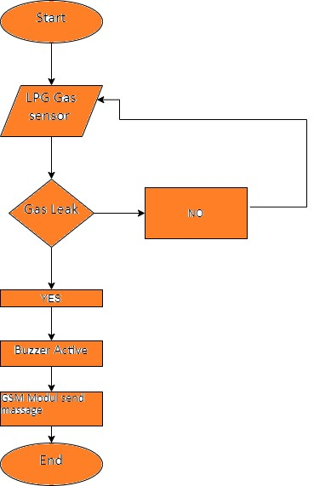

Figure 1(information sourcing flow chart)

D. block diagram
in This structure of Figure 2 the idea behind intelligent gas leakage scheme. It shows different hardware components combined, their connections and the data flowing in this scheme. In this structure, the MQ5, Gas leakage detector, Buzzer, and LCD screen rate percent are all devices are also connected to the Arduino UNO in order to obtain the objective of automatic measuring the conditions of the gas and to perform the suitable decision depends upon the current status. The results can be recorded using Arduino
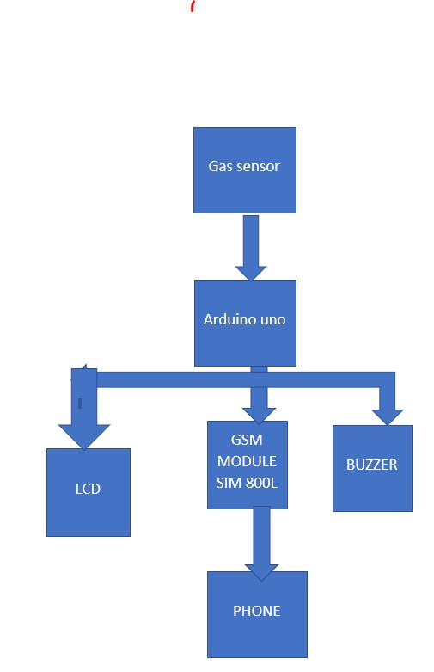
Figure 2 (block diagram)

E. mq5 sensor
A gas sensor is a device which detects the presence of gas in an area. This sensor interacts with a gas to measure its concentration. Each gas has a unique breakdown voltage i.e. the electric field at which it is ionized. Sensor identifies gases by measuring these voltages. The concentration of the gas can be determined by measuring the current discharge in the device. The MQ5 gas sensor detects the presence of various gases such as hydrogen, carbon monoxide, methane and LPG ranging from 100ppm to
3,000ppm

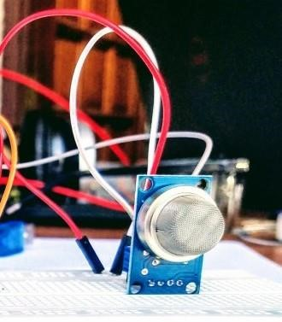
Figure 3 (mq5 sensor)
IV. IMPLEMENTATION
implementation steps, and results. The obtained result has been implemented using figures to simplify comparison between different parameters, finally the actual result of the gas leakage detector through SMS.

A. buzzer
Buzzers can be found in alarm devices, computers, timers and confirmation of user inputsuch as a mouse click or keystroke. You will also learn how to use tone () and noTone ()function. How does it work? It's simple, tone (buzzer, 1000) sends a 1KHz sound signal topin 9, delay (1000) pause the program for one second and noTone(buzzer) stops the signal sound shown in Figure 4.
Figure 4(buzzer)

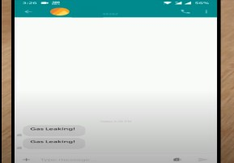

B. LCD screen
An LCD (Liquid Crystal Display) screen is an electronic display module and has a wide range of applications. A 16x2 LCD display is very basic module and is very commonly used in various devices and circuits. A 16x2 LCD means it can display 16 characters per line and there are 2 such lines. In this LCD each character is displayed in 5x7 pixel matrix. as The 16 x 2 intelligent alphanumeric dot matrix display is capable of displaying 224 different characters and symbols. This LCD has two registers, namely, Command and Data. Use the 16x2 standard alphanumeric LCD display, they are extremely common and is a fast way to have your project show status messages like gas average then will show very easy The gas is sometimes low and sometimes high and then it will be easier for you to make a calm decision because you will see where it goes Figure 5 (LCD showing)
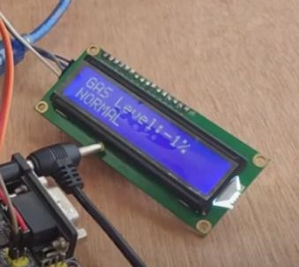
Figure 6(lcd)
C. SMS Protocol for send and reserved
The GSM module with type SIM800A is a module for sending actual data from the system to the SIM card with a GSM network. This module can be used in conjunction with Arduino, which makes it easier for users to create programs related to sending and receiving SMS messages
Figure 9 (sending SMS)

A. Recommendation for Future Work
Based on the conclusion of the research, the proponents formulated several recommendations for the study. The group would like to recommend to the future researchers that they continue to develop this prototype device to find a way to include the manipulation of LPG tank handwheel and anything that will help the proposed project.:
- Getting the details of the concentration levels of the house within a tap of a button]
- Since it is a safety device it is important for it to be perfectly calibrated and maintained at all times. The app can make sure to send reminders about getting the system checked every once in a while.
- This device can be made more enhanced in future to support automatic fire fighting system
- Flat patch antennas are not as advanced and must maintain an upright position to receive coverage. Reliable radio frequency (RF) technology, cellular towers and Advanced Forward Link Trilateration (AFLT) can also be paired with GSM to enhance system accuracy

REFERENCES
- J. Christian and N. Komar, "Prototipe Sistem
Pendeteksi Kebocoran Gas LPG Menggunakan
Sensor Gas MQ2, Board Arduino Duemilanove,
Buzzer, dan Arduino GSM Shield pada PT. Alfa Retailindo (Carrefour Pasar Minggu)," Jurnal TICOM, pp. 1-7, 2013.
- T. H. Mujawar, V. D. Bachuwar, M. S. Kasbe, A. D. Shaligram and L. P. Deshmukh, "Development of wireless sensor network system for LPG gas leakage detection system," International Journal of Scientific & Engineering Research, vol. 6, pp. 16, 2015..
- M. F. Putra, A. H. Kridalaksana and Z. Arifin,
"rancang bangun alat pendeteksi kebocoran gas lpg dengan sensor mq-6 berbasis mikrokontroler melalui smartphone android sebagai media informasi," jurnal informatika mulawarman, vol. 12, pp. 1-6, 2017.

- Zhu, L., Zhang, L., Fan, J., Jiang, P., & Li, L. (2016). MSW to synthetic natural gas: System modeling and thermodynamics assessment. Waste Management, 48, 257–264.
- Malama, A., Mudenda, P., Ng'ombe, A., Makashini, L., & Abanda, H. (2014). The Effects of the Introduction of Prepayment Meters on the Energy Usage Behaviour of Different Housing Consumer Groups in Kitwe, Zambia. AIMS Energy, 2(3), 237259.
- Darby, S. (2006). The effectiveness of feedback on energy consumption.

