A Somali Speaking Mobility Aid for Blind and Visually Impaired People
Mansour Abdalla Abdirahman¹, Mohamed Moalim Ali Abdi², Mohamed Hirsi Olaad³, Halima Abdikarim Hassan⁴
Kingzubeir10@gmail.com, Maheesh@just.edu.so, mohaolady0960@gmail.com , lastqueen288@gmail.com
Faculty of Computer and Information Technology
Jamhuriya University of Science and Technology Mogadishu-Somalia

Abstract - People with disabilities, specially the blind have major difficulties in moving alone so they usually depend on others. The primary tools they used for movement is the traditional walking stick to detect objects on their ways. Smart sticks, also known as walking canes, or ultra-cane came as a proposed solution to enable blind to identify the world around them more conveniently. Somali people with disabilities suffer more than their worldwide counterparts because of the scarcity of smart mobility aids that they can easily adopt and understand.
In this work, we propose and implement a Somali language speaking smart stick for the visually impaired people to improve their mobility and independence in their daily life. This tool is especially useful for those who have difficulty in comprehending vibration features provided by some smart sticks. The stick can detect objects in the range of between 2 cm to 200 cm. When an object is detected, a sound from the SD Card Module through the airphone will alert the user (in Somali Language), about the object to safely avoid it. A moisture sensor to detect the water and LDR to detect light and dark situations are also provided. C++ programming language was used to implement features in the stick. Our new mobility aid was tested by blind and showed their appreciation and recommended it development to commercial or full usage stage.
Keywords – Blind, Ultrasonic Sensor, Moisture Sensor, LDR Sensor, SD Card Module, Visually Impaired.
I. INTRODUCTION
Visually Impaired people face difficulty in interacting and feel disconnected from the environment. The physical movement is challenge for visually impaired people, as it can become tricky to distinguish obstacles appearing in front of them, and these people are not able to move from one place to another place as freely as possible. They depend on someone for mobility. They also have to depend for financial support on their families. This opposes them participating in social activities. Different systems are designed with limitations without a solid understanding of the no visual perception[1].
Vision is the foremost vital portion of human physiology as 83% of data human being gets from the environment is through locating [2]. The life of blind people is very difficult and challenging, they can’t see an object in front them and sometimes they can get hit by object even human and it actually can lead to injures and big problems. The number of visually impaired people are expected to grow in the future due to various reasons. Visual information is the support for most navigational tasks, so visually impaired people are facing difficulties because of lack of necessary information about the surrounding environment and atmosphere. They are not able to distinguish where he/she is, and how to get where he/she wants to go from one place to another. To navigate unknown places, they should bring a sighted family member or a friend for support. Over half of the legally blind people in the world are unemployed. Because the types of jobs they can do is limited. They have a less percentage of employment. They are relying on their families for mobility and financial support[3]
II. METHODS AND MATERIALS
In this paper, we have programmed a blind stick with several sensors for helping and guiding the visually impaired person to navigate. The proposed mobility aid stick will talk to the user whenever the person comes close to an object. The stick informs the user when they have to climb stairs or come down from the stairs. The stick also informs when the stick comes in contact with water or moisture. In all the above cases, the stick communicates to the person through Somali language.
Requirements
- Ultrasonic Sensor is used to detect and measure the distance between the object and the user (blind person).
Ultrasonic sensors or ultra-motion locators are an electronic unit that contains numerous sub electronic circuits in it and has numerous applications.
- Moisture Sensor that is used to detect or sensor water and any solid elements
- LDR Sensor that is used to detect Light and Dark Situation
- SD Card Module is used to produce or output a sound as an alarm for keeping save the blind person.
- Memory Card (2GB Size) is used to store voices and sounds and also connected with SD Card Module.
- Arduino is an open-source tool and used to connect all of these devices. Arduino Software is an open-source and used for coding your program and it uses C++ Language.
III. ANALYSIS AND DESIGN
A. ULTRASONIC SENSOR
The ultrasonic sensor is used to measure distance, meaning it will calculate the distance between itself and the object in front of it, so we have used four ultrasonic, and we know they all doing the same thing calculating distance, but there is a trick of using these four ultrasonic. Ultrasonic 1, 3, 4 calculating distance of the object in front of the stick, ultrasonic 2 is used to calculate the object under the stick
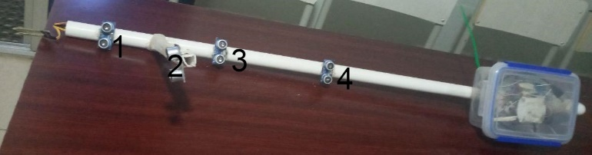
Here is the logic of using the four ultrasonic sensors:
- If ultrasonic 1, 3, 4 returned the same distance or value that means:
  - There is an obstacle in front of the stick
  - Or there is nothing in front of the stick
- If ultrasonic 1,3 returned the same result or value but the ultrasonic 4 returned different results that mean the blind person is in front of spacious land or stairs.
- And the ultrasonic 2 only returns if there is a hole or crater.
B. MOISTURE SENSOR
This sensor is used to detect whether the blind person fell into the water or standing where there is water, meaning we can detect and protect the blind person from the water.
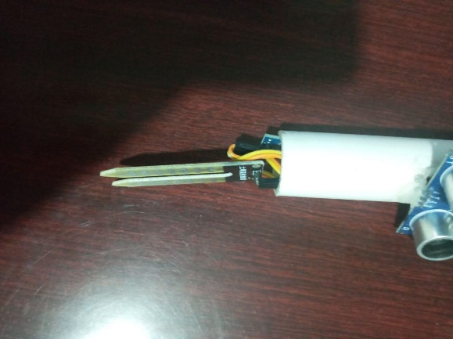

C. LDR SENSOR
The LDR (Light Dependent Resistor) sensor is made up of semiconductor materials that have tall resistance [3]. It is used to detect whether the blind person is in a dark place or not.
The reason we want to identify if the person is in dark place is, because in the dark place, even sighted people cannot see, and this informs the person that they are in a place where nobody can see.
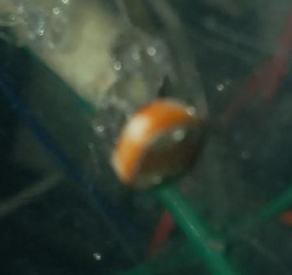
D.SD CARD MODULE
This module is used to store voice or sounds, and this module uses Memory with 2 GB Size for storage. We have used it to store the pre recorded voice to alert the person when they may be in trouble.
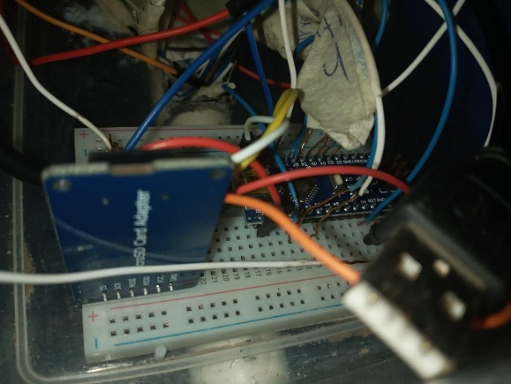

E. ARDUINO NANO
Arduino is the tool that connects between all components we mentioned and also Arduino will get responses from the sensors and outputs to the user.
And the response to the user will be an alarmed voice, the voice is stored in Memory Card, to play the sound or the voice Arduino will call SD Card Module to play a sound and SD Card Module will read the sound from The Memory through an airphone wireless.
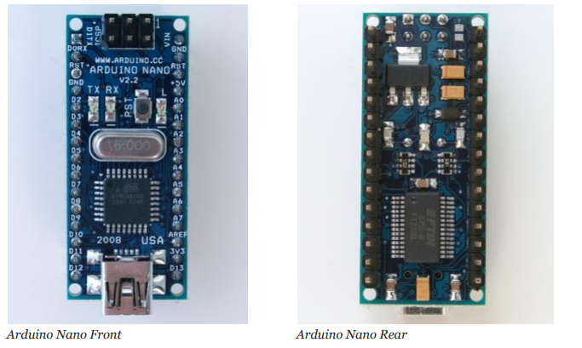
IV. IMPLEMENTATION
The following paragraphs show snippets of the code to configure and program the different sensors.
1. LDR SENSOR
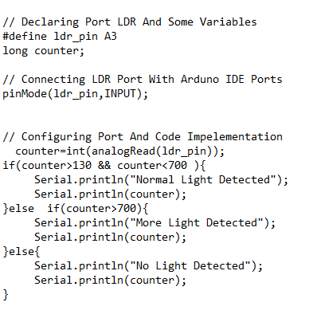

2. MOISTURE SENOSR
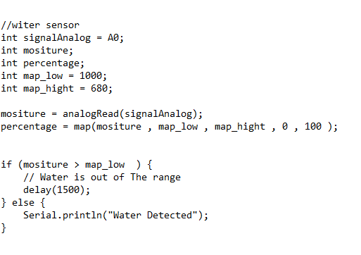
3. ULTRASONIC SENSOR
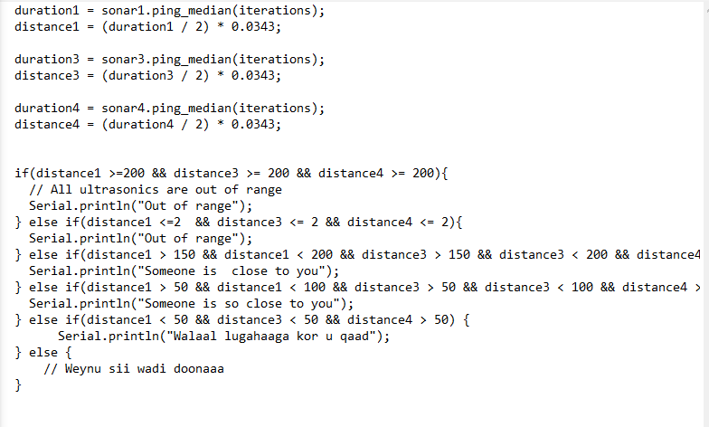
4. SD CARD SENSOR
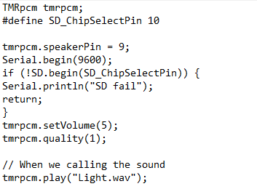
V. DISCUSSION
The establishment of the blind is a long-standing tradition and will continue for many centuries to come, generation after generation is more productive. So, our stick will be compatible with the current generation, and we hope that it continues to evolve, with new ideas and techniques that will help blind people.
So, we completed the study by taking and considering all possible solutions for our system. As we know whatever made by humans is incomplete, meaning if you think that your system is completely possible and working so well is perfect but it’s not perfect but others are thinking that your system needs some configurations and changes.

A. RECOMENDATION FOR FUTURE WORK
We encouraging the researchers who need to take this system and develop to add and configures some tips and ideas which we did not find luck and time by adding these tips.
Here are the tips we needed to update by researchers
- We used Battery 9V but this battery is not a lifetime, so we encourage to find and add a chargeable battery for a life purpose.
- Developing an Android application for the parents and authorities of the blind person to track their people, monitoring their situation, knowing their location, etc.
- Developing a button emergency in the system, so that if the blind person has faced a car crash or a bad situation to call his authorities and parents for taking care of him.
- Adding a switch button for turning on and off the stick easily.
IV. REFERENCES
[1]R. P. Soundarya, Bp. Reddy, A. Akshitha, R. Anusha, and A. Shankar, “SMART BLIND STICK USING ARDUINO,” Int. J. Adv. Res. Comput. Sci., vol. 11, no. Special Issue 1, p. 229, 2020.
[2] Naing, M., Oo, N. N., & Oo, M. T. (2019). Smart Blind Walking Stick using Arduino.
[3]N. B. ROSMAN, “SMART STICK WITH GPS NAVIGATION AND SENSOR DETECTION.”
[4] Aruna, A., Mol, Y. B., Delcy, G., & Muthukumaran, N. (2018). Arduino Powered Obstacles Avoidance for Visually Impaired Person. Asian Journal of Applied Science and Technology, 2(2), 101–106.

